Code:
HTML:
<!DOCTYPE html>
<html lang="en">
<head>
<meta charset="UTF-8">
<meta name="viewport" content="width=device-width, initial-scale=1.0">
<title>Vishwaraj Bhosale | Portfolio</title>
<link rel="stylesheet" href="https://cdnjs.cloudflare.com/ajax/libs/font-awesome/6.4.0/css/all.min.css">
<link rel="stylesheet" href="ass2.css">
</head>
<body>

<nav>
<div class="nav-container">
<button class="nav-tab active" onclick="switchTab('home')">Home</button>
<button class="nav-tab" onclick="switchTab('about')">About</button>
<button class="nav-tab" onclick="switchTab('projects')">Projects</button>
<button class="nav-tab" onclick="switchTab('contact')">Contact</button>
</div>
</nav>

<main>
<section id="home" class="content-section active">
<div class="hero">
<div class="profile-container">
<img src="https://ui-avatars.com/api/?name=Vishwaraj+Bhosale&background=38bdf8&color=fff&size=256" alt="Vishwaraj Bhosale" class="profile-img">
</div>
<h1>Hi, I'm <span id="name">Vishwaraj</span></h1>
<div class="typewriter" id="typewriter"></div>

<p class="hero-sub">Computer Science Undergraduate at MIT-WPU</p>

<div class="cta-container">
<button class="primary-btn" onclick="switchTab('projects')">View My Work</button>
<button class="secondary-btn" onclick="switchTab('contact')">Contact Me</button>
</div>
</div>
</section>

<section id="about" class="content-section">
<div class="about-grid">
<div class="info-card wide">
<h2><i class="fas fa-user"></i> About Me</h2>
<p>
I am a Third-year Computer Science undergraduate at MIT-WPU with a strong interest in problem-solving, algorithms, and machine learning. I am passionate about building solutions that bridge the gap between complex backend logic and intuitive user experiences.
</p>
</div>

<div class="info-card">
<h3><i class="fas fa-code"></i> Languages</h3>
<div class="tags">
<span class="tag">C</span>
<span class="tag">C++</span>
<span class="tag">Java</span>
<span class="tag">Python</span>
</div>
</div>

<div class="info-card">
<h3><i class="fas fa-layer-group"></i> Domains & Web</h3>
<div class="tags">
<span class="tag">Machine Learning</span>
<span class="tag">NLP</span>
<span class="tag">Deep Learning</span>
<span class="tag">HTML/CSS</span>
<span class="tag">Flask</span>
</div>
</div>

<div class="info-card">
<h3><i class="fas fa-database"></i> Databases</h3>
<div class="tags">
<span class="tag">MySQL</span>
<span class="tag">PostgreSQL</span>
</div>
</div>

<div class="info-card wide achievement-card">
<h3><i class="fas fa-trophy"></i> Achievements</h3>
<div class="achievement-item">
<strong>Top 10 Finalist - HackMITWPU'25</strong>
<p>Developed a FinTech solution in a 4-member team, securing a top 10 position among all participating teams.</p>
</div>
</div>
</div>
</section>

<section id="projects" class="content-section">
<h2>Featured Projects</h2>
<div class="projects-grid">

<div class="project-card featured">
<div class="card-header">
<h3 class="project-title">Recipe Meal Planner</h3>
<div class="icons">
<i class="fas fa-utensils"></i>
</div>
</div>
<p class="project-desc">
A full-stack web application where users can browse, search, and manage daily meals. Features include adding/deleting meals to a "My Meals" section, restoring deleted items, and a rating/review system for recipes.
</p>
<div class="tags">
<span class="tag">Flask</span>
<span class="tag">MySQL</span>
<span class="tag">HTML/CSS</span>
</div>
</div>

<div class="project-card">
<h3 class="project-title">Energy Theft Detection</h3>
<p class="project-desc">Machine learning model using Load Curve Regression to identify anomalies in energy consumption patterns.</p>
<div class="tags">
<span class="tag">ML</span>
<span class="tag">Regression</span>
</div>
</div>

<div class="project-card">
<h3 class="project-title">Spam Email Detection</h3>
<p class="project-desc">NLP-based classifier to automatically filter and detect spam emails with high accuracy.</p>
<div class="tags">
<span class="tag">NLP</span>
<span class="tag">Python</span>
</div>
</div>

<div class="project-card">
<h3 class="project-title">Gaming Rage Clustering</h3>
<p class="project-desc">Analysis of gamer behavior patterns using clustering algorithms to identify "Rage" behaviors.</p>
<div class="tags">
<span class="tag">Clustering</span>
<span class="tag">Data Analysis</span>
</div>
</div>

<div class="project-card">
<h3 class="project-title">Bike Repair Estimator</h3>
<p class="project-desc">Time estimation tool for city rental stations to predict bike repair turnaround times.</p>
<div class="tags">
<span class="tag">ML</span>
<span class="tag">Prediction</span>
</div>
</div>

<div class="project-card">
<h3 class="project-title">Anime Recommender</h3>
<p class="project-desc">Recommendation engine generating rules based on user watch history.</p>
<div class="tags">
<span class="tag">Recommendation System</span>
</div>
</div>

</div>
</section>

<section id="contact" class="content-section">
<div class="contact-container">
<h2>Get In Touch</h2>
<p>Feel free to reach out for collaborations or opportunities.</p>

<div class="contact-details">
<a href="mailto:vishwaraj.bhosale@mitwpu.edu.in" class="contact-item">
<i class="fas fa-envelope"></i>
<span>vishwaraj.bhosale@mitwpu.edu.in</span>
</a>
<div class="contact-item">
<i class="fas fa-phone"></i>
<span>+91 9325707757</span>
</div>
</div>

<div class="social-links">
<a href="https://github.com/Vishwaraj-B" target="_blank" class="social-btn"><i class="fab fa-github"></i></a>
<a href="https://linkedin.com/in/vishwaraj-bhosale-419175376" target="_blank" class="social-btn"><i class="fab fa-linkedin"></i></a>
</div>
</div>
</section>
</main>

<footer>
<p>&copy; 2024 Vishwaraj Bhosale. All rights reserved.</p>
</footer>

<script src="ass2.js"></script>
</body>
</html>
CSS:
/* --- CSS VARIABLES & RESET --- */
:root {
--bg-color: #0f172a;
--card-bg: rgba(30, 41, 59, 0.6);
--card-hover: rgba(51, 65, 85, 0.8);
--primary-color: #38bdf8; /* Light Blue */
--accent-color: #a855f7; /* Purple */
--text-color: #f1f5f9;
--text-muted: #94a3b8;
--glass-border: 1px solid rgba(255, 255, 255, 0.1);
--glass-shine: rgba(255, 255, 255, 0.05);
}

* {
margin: 0;
padding: 0;
box-sizing: border-box;
font-family: 'Inter', 'Segoe UI', sans-serif;
scroll-behavior: smooth;
}

body {
background-color: var(--bg-color);
color: var(--text-color);
min-height: 100vh;
display: flex;
flex-direction: column;
overflow-x: hidden;
background-image:
radial-gradient(circle at 15% 50%, rgba(56, 189, 248, 0.08) 0%, transparent 25%),
radial-gradient(circle at 85% 30%, rgba(168, 85, 247, 0.08) 0%, transparent 25%);
}

/* --- NAVIGATION --- */
nav {
display: flex;
justify-content: center;
padding: 1.5rem;
position: sticky;
top: 0;
z-index: 100;
}

.nav-container {
background: rgba(15, 23, 42, 0.7);
padding: 0.5rem 1rem;
border-radius: 50px;
border: var(--glass-border);
backdrop-filter: blur(12px);
display: flex;
gap: 1.5rem;
box-shadow: 0 4px 20px rgba(0, 0, 0, 0.2);
}

.nav-tab {
background: none;
border: none;
color: var(--text-muted);
font-size: 0.95rem;
font-weight: 600;
padding: 0.5rem 1rem;
cursor: pointer;
transition: all 0.3s ease;
border-radius: 20px;
}

.nav-tab:hover {
color: var(--text-color);
background: rgba(255, 255, 255, 0.05);
}

.nav-tab.active {
color: var(--bg-color);
background: var(--primary-color);
box-shadow: 0 0 15px rgba(56, 189, 248, 0.4);
}

/* --- MAIN LAYOUT --- */
main {
flex: 1;
max-width: 1100px;
margin: 0 auto;
padding: 2rem;
width: 100%;
}

.content-section {
display: none;
animation: fadeIn 0.6s cubic-bezier(0.16, 1, 0.3, 1);
}

.content-section.active {
display: block;
}

@keyframes fadeIn {
from { opacity: 0; transform: translateY(10px) scale(0.98); }
to { opacity: 1; transform: translateY(0) scale(1); }
}

/* --- HERO SECTION --- */
.hero {
text-align: center;
padding: 3rem 0;
display: flex;
flex-direction: column;
align-items: center;
justify-content: center;
min-height: 60vh;
}

.profile-img {
width: 160px;
height: 160px;
border-radius: 50%;
object-fit: cover;
border: 4px solid var(--card-bg);
box-shadow: 0 0 30px rgba(56, 189, 248, 0.2);
margin-bottom: 2rem;
}

h1 {
font-size: 4rem;
font-weight: 800;
letter-spacing: -1px;
margin-bottom: 0.5rem;
/* This ensures the "Hi, I'm" part is a bright off-white */
color: #ffffff;
/* We remove the -webkit-background-clip that might be causing the 'black' look */
background: none;
-webkit-text-fill-color: initial;
}

#name {
/* This makes "Vishwaraj" a bright, glowing blue-to-purple gradient */
background: linear-gradient(to right, #38bdf8, #a855f7);
-webkit-background-clip: text;
-webkit-text-fill-color: transparent;
display: inline-block; /* Helps the gradient render correctly */
}

.hero-sub {
color: var(--text-muted);
font-size: 1.1rem;
margin-top: 1rem;
}

.typewriter {
font-size: 1.5rem;
color: var(--primary-color);
font-family: 'Courier New', monospace;
min-height: 1.6em;
font-weight: bold;
}

.cta-container {
margin-top: 2.5rem;
display: flex;
gap: 1rem;
}

button.primary-btn, button.secondary-btn {
padding: 12px 28px;
border-radius: 8px;
font-weight: 600;
cursor: pointer;
transition: transform 0.2s;
font-size: 1rem;
}

button.primary-btn {
background: var(--primary-color);
border: none;
color: var(--bg-color);
}

button.secondary-btn {
background: transparent;
border: 1px solid var(--text-muted);
color: var(--text-color);
}

button:hover {
transform: translateY(-2px);
}

/* --- ABOUT GRID --- */
.about-grid {
display: grid;
grid-template-columns: repeat(auto-fit, minmax(300px, 1fr));
gap: 1.5rem;
}

.info-card {
background: var(--card-bg);
border: var(--glass-border);
padding: 2rem;
border-radius: 16px;
backdrop-filter: blur(10px);
}

.info-card.wide {
grid-column: 1 / -1;
}

.info-card h2, .info-card h3 {
margin-bottom: 1rem;
display: flex;
align-items: center;
gap: 10px;
color: var(--text-color);
}

.info-card i {
color: var(--primary-color);
}

.achievement-card {
background: linear-gradient(145deg, rgba(30, 41, 59, 0.7), rgba(168, 85, 247, 0.1));
border: 1px solid rgba(168, 85, 247, 0.3);
}

.achievement-item {
border-left: 3px solid var(--accent-color);
padding-left: 1rem;
margin-top: 1rem;
}

/* --- PROJECTS GRID --- */
.projects-grid {
display: grid;
grid-template-columns: repeat(auto-fill, minmax(300px, 1fr));
gap: 1.5rem;
margin-top: 2rem;
}

.project-card {
background: var(--card-bg);
border: var(--glass-border);
border-radius: 16px;
padding: 1.5rem;
transition: all 0.3s ease;
display: flex;
flex-direction: column;
}

.project-card.featured {
grid-column: 1 / -1;
background: linear-gradient(to bottom right, var(--card-bg), rgba(56, 189, 248, 0.1));
border-color: rgba(56, 189, 248, 0.3);
}

.project-card:hover {
transform: translateY(-5px);
background: var(--card-hover);
border-color: var(--primary-color);
}

.project-title {
font-size: 1.2rem;
color: var(--text-color);
margin-bottom: 0.5rem;
}

.featured .project-title {
font-size: 1.5rem;
color: var(--primary-color);
}

.project-desc {
color: var(--text-muted);
font-size: 0.95rem;
line-height: 1.6;
margin-bottom: 1.5rem;
flex-grow: 1;
}

.tags {
display: flex;
gap: 0.5rem;
flex-wrap: wrap;
}

.tag {
font-size: 0.75rem;
background: rgba(255, 255, 255, 0.05);
color: var(--primary-color);
padding: 0.3rem 0.8rem;
border-radius: 20px;
border: 1px solid rgba(56, 189, 248, 0.2);
}

/* --- CONTACT --- */
.contact-container {
background: var(--card-bg);
border: var(--glass-border);
border-radius: 20px;
padding: 3rem;
text-align: center;
max-width: 600px;
margin: 2rem auto;
}

.contact-details {
margin: 2rem 0;
display: flex;
flex-direction: column;
gap: 1rem;
align-items: center;
}

.contact-item {
display: flex;
align-items: center;
gap: 10px;
color: var(--text-color);
text-decoration: none;
font-size: 1.1rem;
transition: color 0.2s;
}

.contact-item:hover {
color: var(--primary-color);
}

.social-links {
display: flex;
justify-content: center;
gap: 2rem;
margin-top: 1.5rem;
padding-top: 1.5rem;
border-top: 1px solid rgba(255,255,255,0.1);
}

.social-btn {
font-size: 2rem;
color: var(--text-muted);
transition: all 0.3s;
}

.social-btn:hover {
color: var(--primary-color);
transform: scale(1.1);
}

/* --- FOOTER --- */
footer {
text-align: center;
padding: 2rem;
color: var(--text-muted);
font-size: 0.9rem;
margin-top: auto;
border-top: 1px solid rgba(255,255,255,0.05);
}

/* Mobile Adjustments */
@media (max-width: 768px) {
h1 { font-size: 2.5rem; }
.nav-container { padding: 0.5rem; width: 100%; justify-content: space-between; overflow-x: auto; }
.nav-tab { font-size: 0.85rem; padding: 0.5rem 0.8rem; }
.contact-container { padding: 1.5rem; }
}

JS:
// --- TAB SWITCHING LOGIC ---
function switchTab(tabId) {
// 1. Hide all sections
const sections = document.querySelectorAll('.content-section');
sections.forEach(section => {
section.classList.remove('active');
});

// 2. Show the selected section
const selectedSection = document.getElementById(tabId);
if (selectedSection) {
selectedSection.classList.add('active');

// Reset animations for child elements if you want them to re-animate
// This is optional but adds a nice touch
const children = selectedSection.children;
for(let child of children) {
child.style.animation = 'none';
child.offsetHeight; /* trigger reflow */
child.style.animation = null;
}
}

// 3. Update Nav Buttons
const navButtons = document.querySelectorAll('.nav-tab');
navButtons.forEach(btn => {
btn.classList.remove('active');
// Check if the button's click handler targets this tabId
if (btn.getAttribute('onclick').includes(`'${tabId}'`)) {
btn.classList.add('active');
}
});

// Smooth scroll to top when switching
window.scrollTo(0,0);
}

// --- TYPEWRITER EFFECT ---
const textElement = document.getElementById('typewriter');
// Personalized phrases based on Vishwaraj's skills
const phrases = [
"Machine Learning Enthusiast",
"Problem Solver",
"Python & C++ Developer"
];
let phraseIndex = 0;
let charIndex = 0;
let isDeleting = false;
let typeSpeed = 100;

function type() {
const currentPhrase = phrases[phraseIndex];

if (isDeleting) {
textElement.textContent = currentPhrase.substring(0, charIndex - 1);
charIndex--;
typeSpeed = 50; // Faster when deleting
} else {
textElement.textContent = currentPhrase.substring(0, charIndex + 1);
charIndex++;
typeSpeed = 100; // Normal typing speed
}

if (!isDeleting && charIndex === currentPhrase.length) {
isDeleting = true;
typeSpeed = 2000; // Pause at end of phrase
} else if (isDeleting && charIndex === 0) {
isDeleting = false;
phraseIndex = (phraseIndex + 1) % phrases.length;
typeSpeed = 500; // Pause before next phrase
}

setTimeout(type, typeSpeed);
}

// Initialize animations and effects
document.addEventListener('DOMContentLoaded', () => {
type();

// Optional: Add simple fade-in for project cards on scroll if needed in future
// using IntersectionObserver
});

Output:

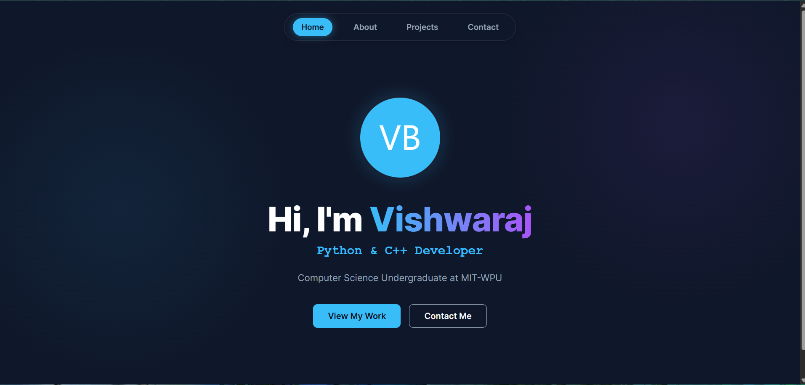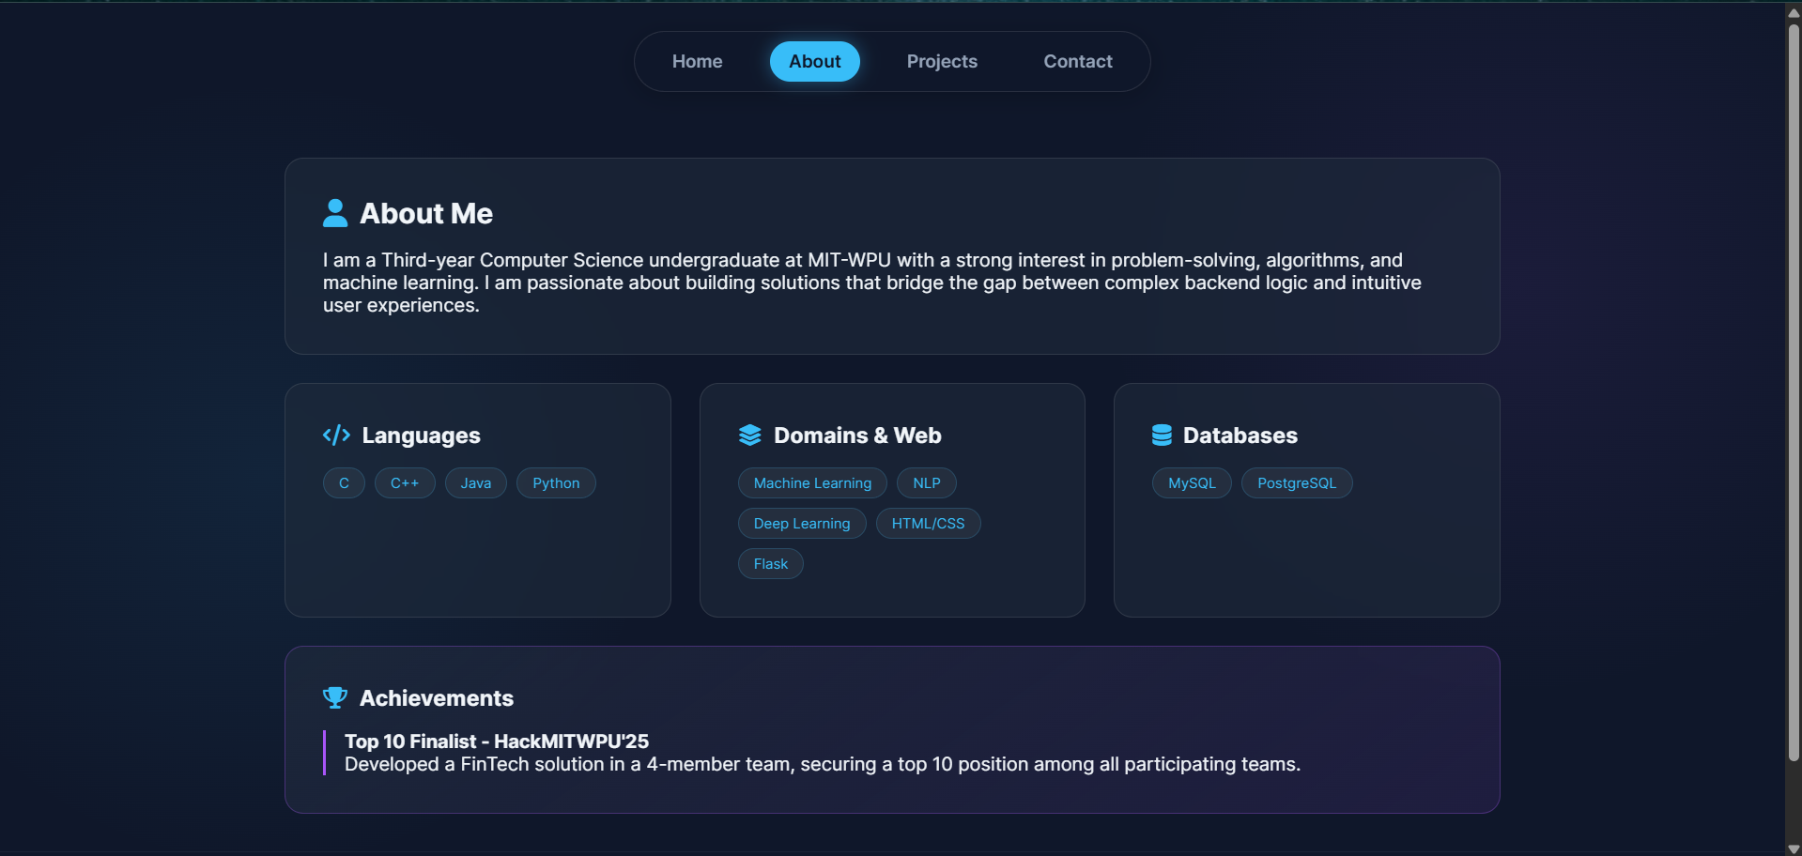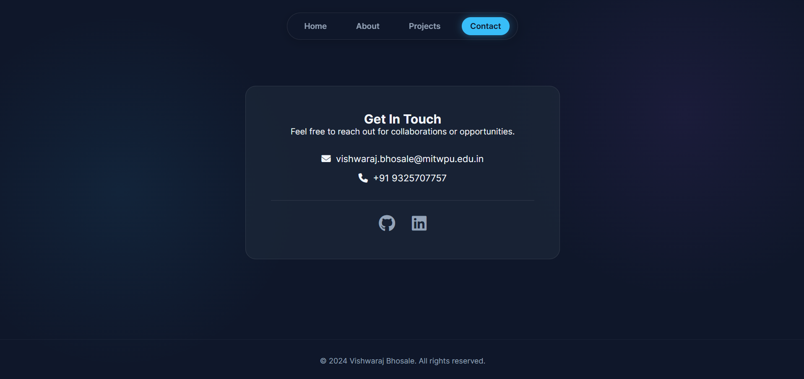

FAQ:
